Performance Range 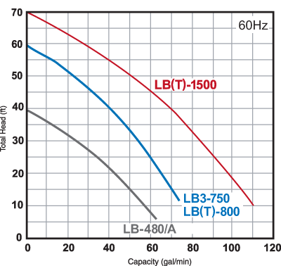

Model | Discharge Bore (inch) | Shipping Weight | Cable Length | Diameter | Height
LB-1500 | 2/3 | 85 | 50 | 7 3/8 | 23 5/8
LB3-750 | 2 | 43 | 50 | 7 5/16 | 16 1/4
LB-480 | 2 | 28 | 32 | 7 3/8 | 11 3/16
LB-480A | 2 | 30 | 32 | 7 3/8 | 11 3/16
LBT-1500 | 2/3 | 85 | 50 | 7 3/8 | 23 5/8
LBT-800 | 2 | 30 | 50 | 7 1/2 | 13 7/16

