Performance Range 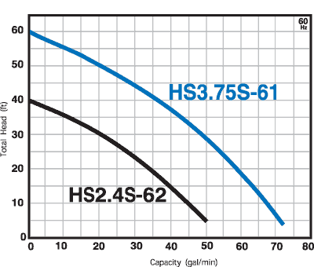

Model | Discharge Bore (inch) | Shipping Weight | Cable Length | Diameter | Height
HS3.75S-61 | 3 | 25 | 20 | 10 | 13
HSD2.55S-61 | 2 | 33 | 16 | 6 3/8 | 15 3/8
HSZ3.75S-61 | 3 | 42 | 32 | 12 1/2 | 15 1/4
HSZ2.4S-62 | 2 | 25 | 20 | 10 | 13
HS2.4S-62 | 2 | 25 | 20 | 10 | 13

