
Florian Eichinger GmbH
An der Lände 10
92360 Mühlhausen
Germany
Tel: +49 9185 923 0
Fax: +49 9185 923 333
info@eichinger.de
www.eichinger.de
OPERATING INSTRUCTIONS
for FE 1025 (H) CONCRETE SKIP

- Intended Use and Description
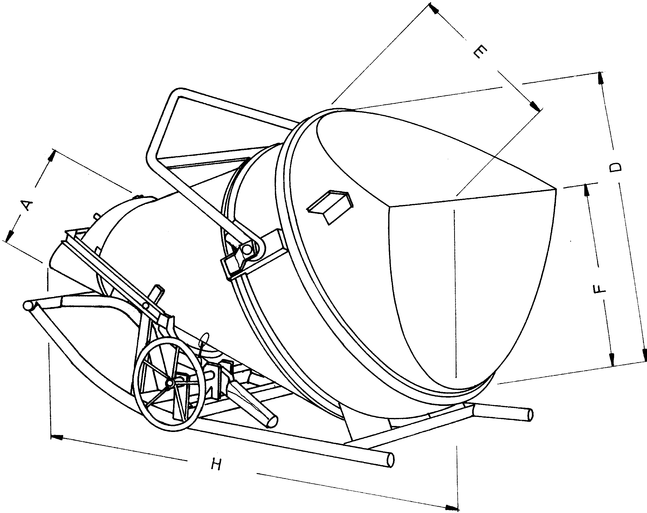
The concrete skip FE 1025 (H) is designed to transport liquid concrete from the mixer to the place of use with help of a crane.
This skip is characterised by its low filling height (when the skip is set horizonlally) as well as by its lateral outlet.

- First use
The concrete skip FE 1025 (H) is delivered fully assembled.
According to accident prevention regulations, the concrete skip may only be put to use after it has been inspected by a suitably qualified person and after all defects found in the inspection have been rectified.

- Operation
Before filling the concrete skip, secure the clamping lever on the discharge gate. The discharge gate must be hung to the hook at the foot of the skip. This will prevent unintentional emptying of the skip and uncontrolled concrete flow.

Make sure the skip is secured against tipping over during the whole filling process, for example by hanging the chain to the crane hook. Make sure the transport beam can move freely inside the crane hook ( use a safety hook).
Fill the skip with liquid concrete and transport it to its place of use with a crane. Do not allow persons beneath the load or in the danger zone.
Take into account the bearing capacity of the surface on which the skip is going to be set. According to DIN 4420, an official authorization is required to set the skip on scaffoldings.
Only set the skip on horizontal surfaces.

Before emptying the skip, unhook the discharge gate and unlock the clamping lever on the discharge gate. Use the lever or handwheel to open the discharge gate.

- Maintenance
Grease all joints and make sure they move smoothly.
Check that the skip is not deformed.
Check the transport beam regularily.

- Inspections
According to safety regulations, the concrete skip must be inspected by a specialist at least once a year or more often depending on the conditions of use and on the owner´s needs.
Inspections should focus on signs of wear, deformations, tears, cracks and rust.

