
Florian Eichinger GmbH
An der Lände 10
92360 Mühlhausen
Germany
Tel: +49 9185 923 0
Fax: +49 9185 923 333
info@eichinger.de
www.eichinger.de
OPERATING INSTRUCTIONS
for FE 1019 (H) CONCRETE SKIP

- Intended Use and Description
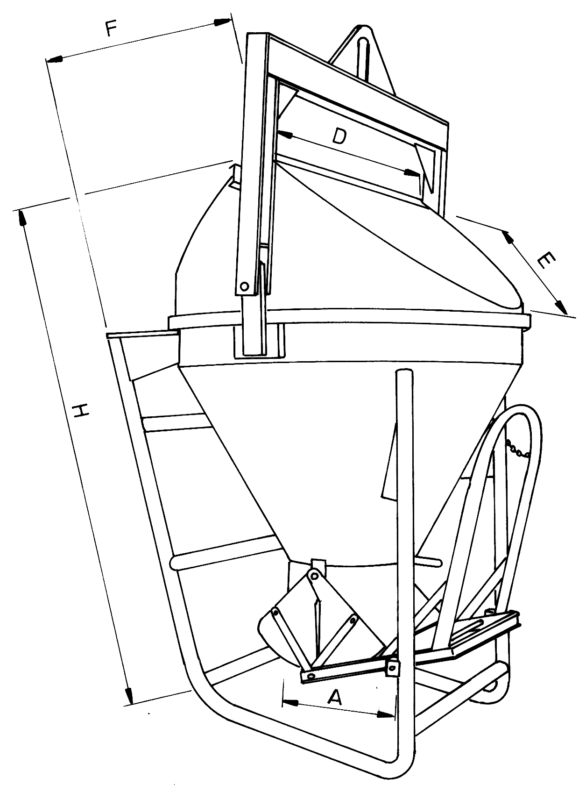
The concrete skip FE 1019 (H) is designed to transport liquid concrete from the mixer to the place of use with help of a crane.
This skip is characterised by its horizontal cylindrical-conical shape.

- First use
The concrete skip FE 1019 (H) is delivered fully assembled.
According to accident prevention regulations, the concrete skip may only be put to use after it has been inspected by a suitably qualified person and after all defects found in the inspection have been rectified.

- Operation
Before filling the concrete skip, secure handwheel or lever with the safety chain. This will prevent unintentional emptying of the skip and uncontrolled concrete flow.

Fill the skip with liquid concrete and transport it to its place of use with a crane. When filling, the concrete should run straight into the skip. If this is not the case, the skip must be secured against tipping over during the whole filling process, for example by hanging the chain to the crane hook.

Take into account the bearing capacity of the surface on which the skip is going to be set. Do not set the skip on scaffoldings and such, unless their bearing capacity has been guaranteed.
Only set the skip on horizontal surfaces.

The standard version skip is delivered with a 3 meter long rubber hose and a 3 m long pull cable.
Pull the cable to open the discharge gate. Concrete will flow out of the funnel and into the formwork. When the skip is empty, a compression spring will close the gate automatically.

- Maintenance
Grease all joints and make sure they move smoothly.
Check that the skip is not deformed.
Check chains regularily according to DIN 685. Check them twice a year and test them once a year (DIN 685).

- Inspections
According to safety regulations, the concrete skip must be inspected by a specialist at least once a year or more often depending on the conditions of use and on the owner´s needs.
Inspections should focus on signs of wear, deformations, tears, cracks and rust.

