[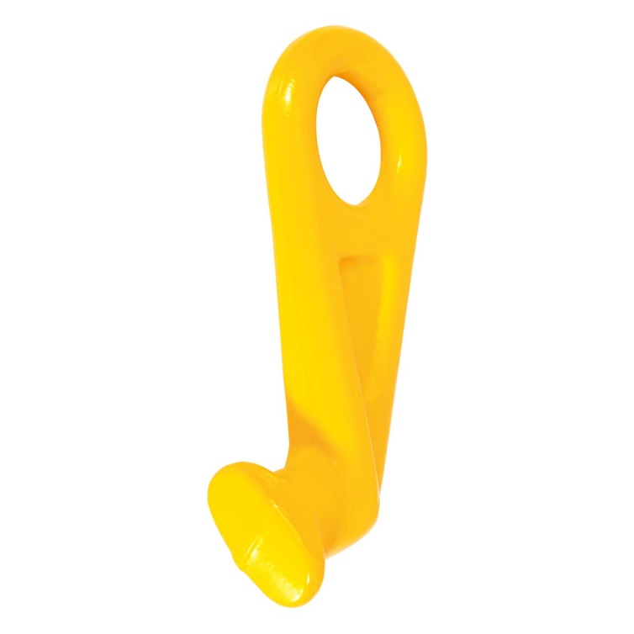](http://www.google.nl/url?sa=i&rct=j&q=&esrc=s&source=images&cd=&cad=rja&uact=8&ved=0ahUKEwjPtue5tLrSAhXDxxQKHYECDcYQjRwIBw&url=http%3A%2F%2Fwww.prolux-shop.com%2Fse_sv%2Fcontainerkrok.html&psig=AFQjCNHLOmRNGPwIb9udfJ5q-OeazpeXaw&ust=1488633032143812)

[](http://www.google.nl/url?sa=i&rct=j&q=&esrc=s&source=images&cd=&cad=rja&uact=8&ved=0ahUKEwjwo_vltbrSAhWJShQKHbp-CGMQjRwIBw&url=http%3A%2F%2Fwww.prolux-shop.com%2Fit_de%2Fcontainerhaken.html&bvm=bv.148747831,d.ZGg&psig=AFQjCNGqPdL9V97C_Wu0ygE0iTCtOdLTMw&ust=1488633395417570)