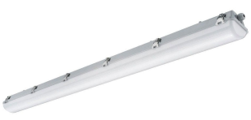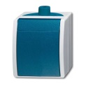[](https://www.google.nl/url?sa=i&rct=j&q=&esrc=s&source=images&cd=&cad=rja&uact=8&ved=2ahUKEwiQ7pmkmKfhAhULsaQKHdoLBckQjRx6BAgBEAU&url=https://www.arbeidsveiligheid.net/tools/aarding-symbool&psig=AOvVaw1TTmcCMlsacD1em-fvP4lS&ust=1553943363931869)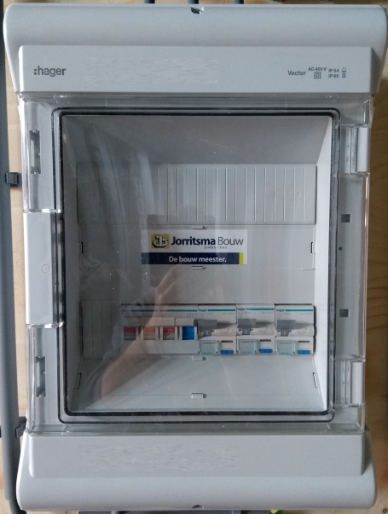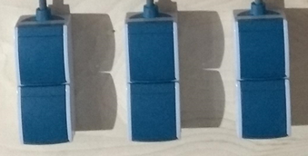

2e golf

4e golf

120 mm

500 mm

610 mm

1200 mm

Voeding

L1

L3

L2